Mister B.  Living with a 98-Year-Old Rocket Scientist  By A. Lynn Byk  Tip Sheet | 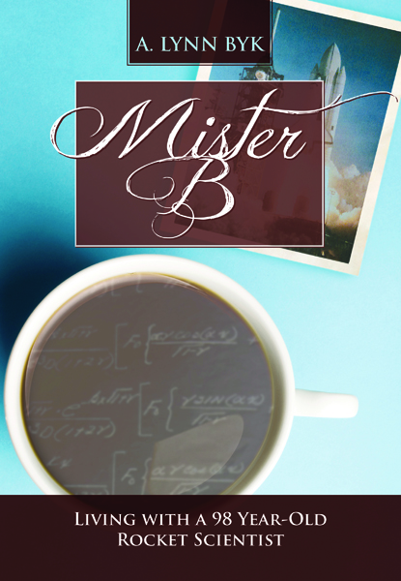
Format: | hardcover/trade 6 x 9 paperback/mass market paperback/ebook
Price: | $22.00 paperback $35.00 hard cover $6.99 eBook/ePub
First Printing: | Yes
Ships: | Immediately and is Returnable in the U.S. and Canada
Trim Size: | 6.69" x 9.61" (16.993 x 24.409 cm)
Pages: | 352
Illustrations: | 50 black and white
Foreign rights: | Full global rights
Category:  Subjects:  Classification: | Autobiography/memoir/ Humor/  Aerospace/WWII and Cold War  LCSH: Byk, Joseph John. | Aging parents-Family Relationships/ Engineers-Family relationships. | Older men-Family relationships. | Intergenerational relations.  LCC HQ1063.6 .B95 2016 (print) | LCC HQ1063.6 (ebook) | DDC 306.8740846-dc23 |  BISAC HUM011000 HUMOR / Topic / Marriage & Family
Capture Books ISBN: | (Hard Cover) 978-0997162561  (Print) 978-0997162509 / eBook/ePub: 978-0-9971625-1-6

Keynote
When family members of a 98-year-old aerospace scientist decide to move in as his caretakers, he determines to live forever taking them with him for the ride of their lives.

Positioning

Book clubs will find a list of book club questions at www.CaptureMeBooks.com. Philosophers and humanitarians, aerospace & history hounds, social studies and math students find inspiration for life and career. Humorists and Comedians can find samples and excerpts on the Capture Me Books website.

Sales Points

Just picked up by Ingram, with similarities to Forrest Gump and Tuesdays with Morrie, a wry and witty humor meet scientific philosophies of life, finding conflicts and resolutions within the triangle of family relationships. Foodies, mushroom collectors, lovers of history and life inspiration become devoted to Mister B.

Description
Born in 1916 to Polish speaking immigrants, Joseph Byk begins his schooling as a disruptive and uninterested Woonsocket, Rhode Island student. He helps to design the BT-13, the Vibrator, the repairs to the FDR Ship, and eventually the Gemini Space Shuttle, the Titan, the Viking Lander, the first Apollo Spacecraft dome and man-rated capsule and the tripod for the moon’s landing gear.

About The Author

Author Lynn Byk is the daughter-in-law who, being obligated to become Joseph Byk’s companion, gradually was wooed over by her father-in-law’s stories, humor and scientific outlook on life. Previously, she managed a bookstore, developed a writer’s group and a musicians’ network, and published a music zine. More recently, she organized a writers conference, hired a national keynote speaker, Lynn also presented, published and she helps her fellow authors with PRW, Cison, Facebook, Twitter, Pinterest and eBlasts. She has also traveled extensively.

Marketing/Publicity
- Blog Tour, Virtual Book Club Tour, Offering Free Books to Math and Social Studies teachers who promote the book to students throughout 2016; News Releases through PRWeb and Cison 55% discount to library systems and author appearances; Facebook and Twitter social marketing including Mister B’s countdown to 100; Radio interviews; Help A Reporter Out with op-eds and bylines; Author/Promoter/Presenter at The Perfect Pitch Writers Conference.
- Publicity/ Sales Promotion: Hardcover and print: 55% discount to Libraries, Retailers and Indibound stores through www.CaptureMeBooks.com and Ingram; Targeted eblasts and catalog inclusions cross marketing all of www.CaptureBookstore.com selections.

Competition/Comparisons
- Tuesdays with Morrie, [ Doubleday, print $10.00, ISBN:76790592X] 1997, In Print
- Forrest Gump, [ Perch Creek Realty and Investment Corps., Vintage Books, print $10.50, ISBN: 0385231342] 1986, Currently In Print

