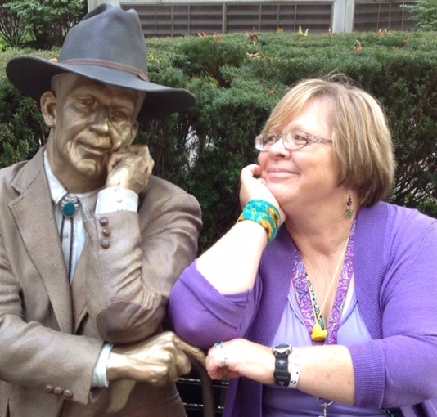
Kathy Joy 720.210.7107
SPEAKS
WONDER
PRESENTATION PROPOSAL
During her decades-long radio career in the Denver, Colorado area, Kathy Joy was an often-sought-after speaker for MOPS. In the trenches herself with mothers of young children, Kathy brought a gritty and funny, uncut approach to the daily realities – including,
- Who Are These People in the Back Seat and Why Do They Keep Calling Me Mom?
- Bubble Wrap: The Affordable Alternative to Therapy.
After relocating to her home area of rural Pennsylvania with her family, Kathy endured the sudden loss of her husband, Roger. To cope with her grief, Kathy began collecting three beautiful moments each day; these collections became seasonal coffee table books, each singing home the passageways of the heart.
Now, equipped with the reluctant wisdom of widowhood and having raised two children on her own, Kathy brings a new depth to her talks, encouraging moms in all seasons of the holy calling that is parenting. Find her Everyday Celebrations blog here: https://www.facebook.com/speakwonder/
- A favorite topic she presents is Harbor Pilots I Have Known – a vibrant and faithful testimony to the Encouragers who help us find safe harbor.
- Women’s retreats and conferences can also expect Kathy Joy’s facilitation of life coaching/ vision board workshops and other poetry of life.
Kathy Joy’s debut book, Breath of Joy! Simply Summer is a collection of captured moments and images to surprise and sustain us. Since her pilot book, Kathy has published two others: Breath of Joy! Ah, Autumn and Breath of Joy! Singing Spring. Look for Winter Whispers soon.
Kathy resides in Pennsylvania along the shores of Lake Erie and considers Colorado her home too.

Call or Text! Book. Wonder. Now.
Tweet: @Breath_of_Joy

